We Need Space

Blast through countless waves of incoming alien ships in hopes of saving Earth from total annihilation

The Galaxy Brains: Jackson Blanchard, Nathan Steelman, Hung Tran, and Nicholas Shaffer

# Table of Contents

**Table of Contents** **2**

**Game Design** **3**

Summary 3

Related Games 3

Gameplay 3

Narrative 3

**Technical** **3**

Theming 3

Mechanics 3

Set Up 4

Rules 4

Controls 4

**Design** **4**

Visual Style 4

Inspiration 5

Enemy Models 5

Game Flow 5

**Development** **6**

Playtest Results 6

Future Work 6

Viability 6

Star Wars (1983 Video Game) 6

Star Wars: Squadrons 6

# **Game Design**

## Summary

You play as a lone soldier protecting Earth from invaders - the last line of defense for human kind.

## Related Games

* Galaga
* Star Wars (1983 Video Game)
* Star Wars: Squadrons

## Gameplay

Your goal is to survive for as long as possible by clearing endless waves of enemies. Enemy group size and difficulty scale over time. The idea is that eventually you will be swarmed. No enemy is especially difficult to defeat, but it’s easy to become discombobulated and overwhelmed.

## Narrative

You are Earth’s last line of defense from an incoming galactic hive. The situation is hopeless. You can only give more time to the people back on earth but eventually you will succumb to the swarm.

# Technical

## Theming

Your enemies are a galactic species of aliens who have come to invade Earth. Different classes of enemy ships have different behaviors and attack patterns, but all spawn in waves from a central mothership.

## Mechanics

The game is a 3D space shooter, and you must use your ship’s weapons and your flying abilities to shoot and evade enemies as they try to attack you.

Progress by defeating growing waves with varying enemies and sizes, aiming for a high score with only small pauses in between waves. Acting as obstacles, asteroids litter the battlefield and offer cover but also force you to swerve between them while having to maintain a constant speed. Asteroids also contain powerups and are replenished by a constantly rotating belt of asteroids entering the battlefield. Powerups include a triple shot, black hole, health bonus, faster lasers, and double points. The player has both a health and shield bar, the latter of which regenerates every round. Health persists between rounds, so as long as you get hit less than 4 times a wave, you can go on infinitely. As mentioned, players also have the opportunity to get more health from powerups.

## Set Up

The player starts at the center of the world, with no velocity. From the first time they press the acceleration button it becomes near impossible to return to 0 (except for brief instants while turning).

The first wave to spawn is a small one, and the player must attempt to clear it before it kills them.

## Rules

Score points by clearing many waves quickly and accurately. Bonuses are awarded for quickly clearing a wave, as well as consecutive hits on enemies without missing.

### Controls

| **PC Control** | **Action** |
| --- | --- |
| W | Increase acceleration |
| S | Decrease Acceleration |
| Spacebar/Left Click | Fire weapon |
| Mouse Movement | Move crosshair/pitch and yaw |
| A/D | Roll |
| Right Click | Fire Black Hole (If you have one) |

# Design

## Visual Style

The visual style of the game is that of an arcade shooter. All models will have a vibrant color scheme with a wireframe design to facilitate this styling.

### Inspiration

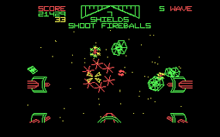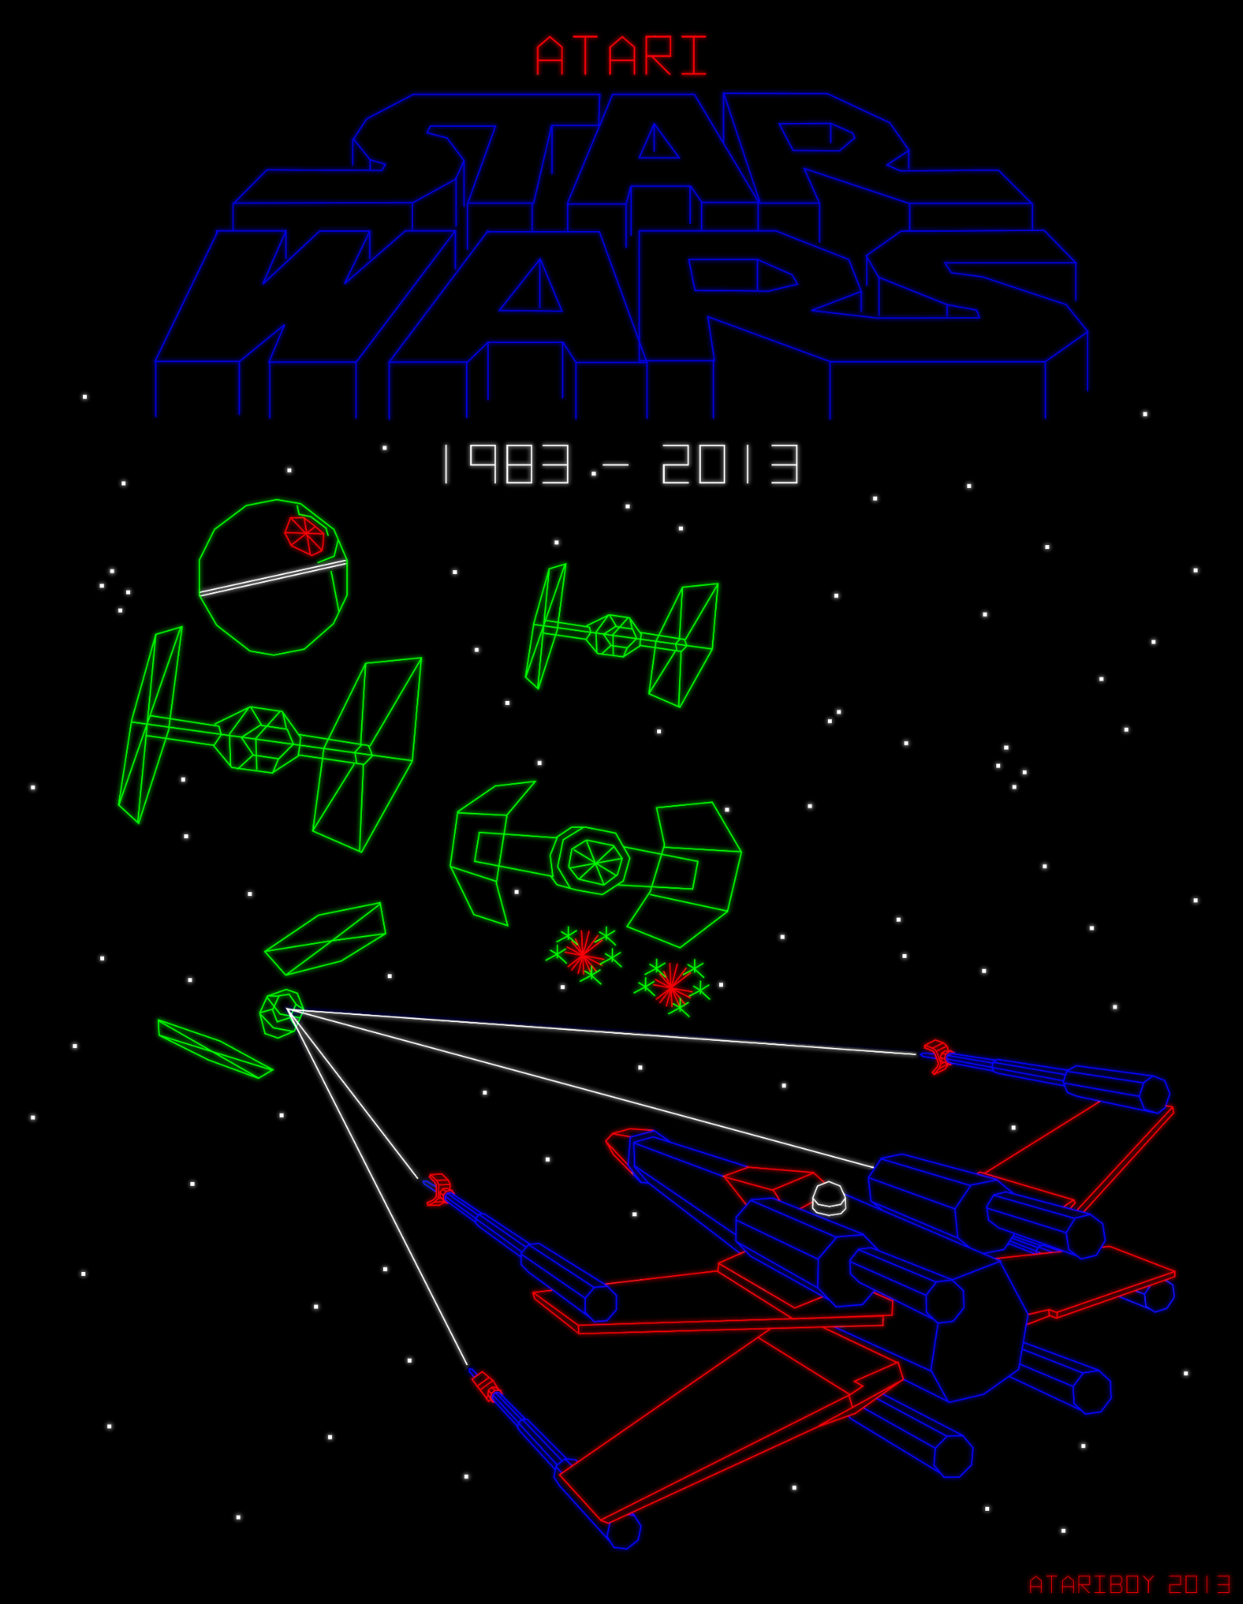

### Enemy Models

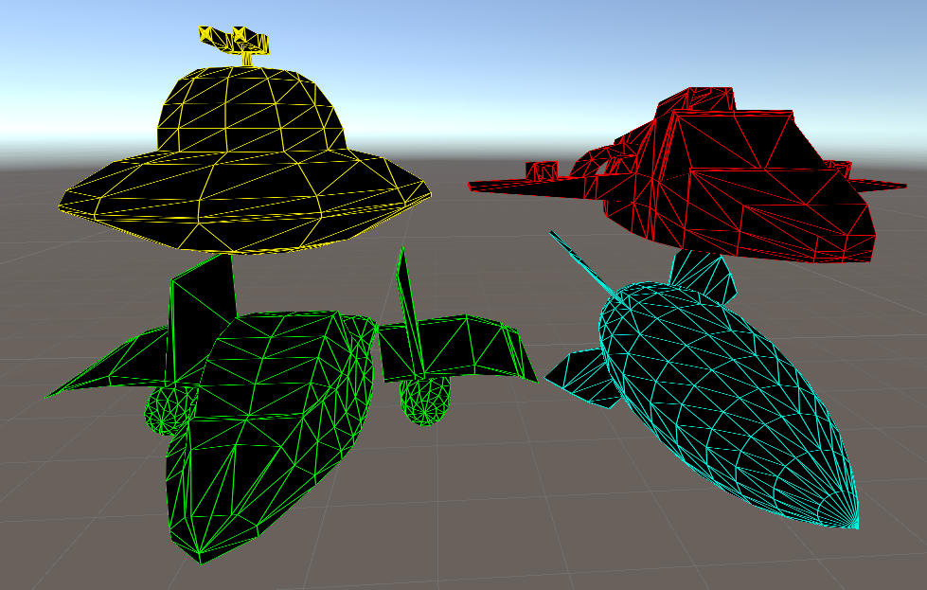

## Game Flow

The game progresses as follows:

1. The player starts at the center of the map
2. From a distance, the first wave of enemies will spawn of varying difficulty and with varying movement patterns
3. The player must destroy every enemy in this wave while trying to avoid taking damage
4. When every enemy in the wave is destroyed, a slightly harder wave will spawn, and your shield will regenerate
5. The game continues until the player is defeated

# Development

## Playtest Results

* The most common issue we found was players not being able to find straggling enemies. We’ve since added a minimap that indicates an enemy’s relative direction from the player as well as that enemy’s type. We’ve also added out of bounds logic to enemies so they can’t wander too far
* Another issue was the players feeling that they were going too slow, and that the movement drifted too much. A “speedlines” visual effect will help illustrate the speed to the player; we suspect the perception of speed was warped by the lack of reference points in a void. Increasing asteroid density should also alleviate this problem, while increases in player acceleration and friction should give the player less drift in their movement
* A few found the lasers to be too slow, we found that was a bug due to the old laser speed in the inspector overriding the speed in the script
* There were also issues with player rotation being too fast. This came down to an issue with how the UI was being scaled up for larger screens and has since been fixed.
* There were a few bugs, largely with time flow due to the pause menu and game over screen. We’ve fixed these bugs

## Future Work

Some things on the backlog that have yet to be implemented include:

* The addition of a third-person perspective
* Extra Enemy Types
* New types of obstacles
* Remappable Controls

## Viability

### Star Wars (1983 Video Game)

This game, which has a similar visual style and similar gameplay, was quite successful. According to Wikipedia, it was “Atari's top-selling 1983 arcade release, with Atari producing 12,695 total arcade units.”

### Star Wars: Squadrons

This game, which has similar gameplay and controls was also relatively successful, with many reviewers praising the combat and flight mechanics. It retains a 7/10 on Gamespot, a 79/100 on Metacritic, and an 8/10 on IGN.